

W9 PRACTICE

QUIZ APP

 Important

✓ The reflection part will be done in teams of 2 (designing) and 4 (sharing) ✓ The coding part needs to be submitted individually

Learning objectives
- Handle navigation between multiple screens – Using a state (not router for now…)
- Pass data between screens
- Separate UI logic from business logic: using a model folder
- Reflect on the best approaches (data, states, widgets) to maintain a clean architecture

How to submit?
- Push your final code on your GitHub repository
- Then attach the GitHub path to the MS Team assignment and turn it in


Functional Requirements

For this practice (W9)
- The player can start the quiz and answer each question one by one
- Only single choice questions
- Once finished, the app shows the score and the questions results

For Bonus
- The history of the previous scores can be reviewed
- The quiz questions and player submission are persisted in JSON file

For next practice (W10)
- The player enters his/her name before starting
- It’s possible to edit the quiz questions

Non-Functional Requirements

- The application must implement the provided user flow and mockups

User Flow

For this practice, the following user flow/mockup are required:

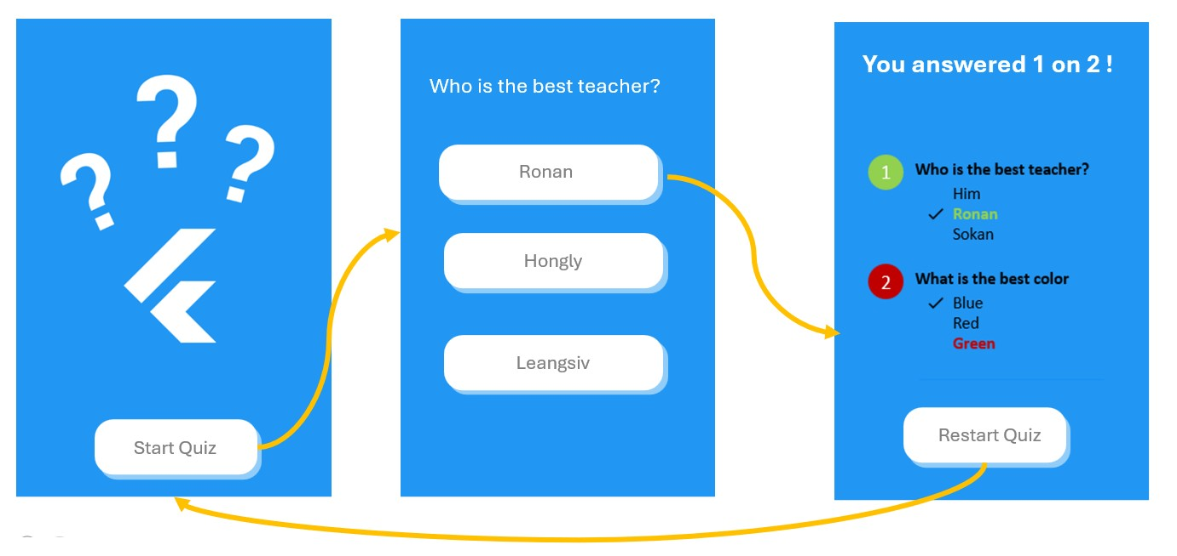

BONUS
To include the history of the previous scores, the user flow can evolve as follows:
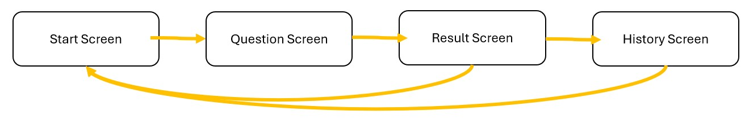

Layer structure
The application is structured around 3 layers: DATA > DOMAIN > UI

data | Repositories to load domain objects from data sources
model | Contain the domain classes
ui/screen | Screen widgets and sub-screen widgets
ui/widgets | Re usable widgets (button, inputs…)

Here is an example of project structure (just an example, not the correct one)

lib/ ├─ data/
│ └─ repositories/
│ └─ quiz_json_repository.dart
│ └─ quiz_mock_repository.dart
├─ models/
│ └─ quiz.dart
│
└─ ui/
├─ screens/
│ └─ welcome_screen.dart
│ └─ question_screen.dart
└─ widgets/
└─ app_button.dart
└─ app_button.dart

main.dart

Layer interaction
- The main loads the quiz data (from mock data or from a Json file)
- The main create the quiz screen, passing the quiz data as parameter

PART 1 – REFLECTIONS

MODEL

To handle the functional requirements for this practice, and be ready for the next practice, how are you going to structure your model?

Q1 – Drop below the UML diagram of your model

{HERE}

Q2 – Where do you keep player submission, so that you can display the last screen?

- In-memory during quiz: In the QuestionScreen state, we maintain a List<int?> answers array where each index corresponds to a question, and the value is the selected option index (or null if unanswered).
- Persistent storage (History): After completing the quiz, the score and quiz details are saved to:
  - Web: Browser's localStorage via HistoryRepositoryWeb
  - Mobile/Desktop: Local file history.json via HistoryRepository

UI – Screens

We have 3 screens (start, question and result)

Q3 – Identify for each widget their properties

WIDGET | TYPE (SL / SF) | PARAMETERS | STATES
StartScreen | SL | quiz: Quiz | None
QuestionScreen | SF | quiz: Quiz | current: int  answers: List<int>
ResultScreen | SF | quiz: Quiz  answers:List<int>  score: int | None (only calls initState to save score)
HistoryScreen | SF | None | history: List<Map<String, dynamic>>

Q4 – Draw the COMPONENT DIAGRAM of the application

{HERE}

Q5 – Where and How do you manage the navigation to the next questions and to the last result screen?

- Between questions within QuestionScreen:
  - State management: current index tracks which question is displayed
  - Next button: Increments current until last question
  - Previous button: Decrements current (disabled on first question)
  - No screen change - just state update within the same screen
- To ResultScreen:
  - When current == questions.length - 1 and user clicks "Finish"
  - Navigator.pushReplacement replaces QuestionScreen with ResultScreen
  - Passes quiz, answers, and computed score as parameters
- Back to StartScreen:
  - Navigator.popUntil(context, (route) => route.isFirst) in ResultScreen
  - This pops all screens until reaching the first screen (StartScreen)

UI – Reusable widget

List down the widget you are planning to re-use on different screens (button, card..)

WIDGET | TYPE (SL / SF) | PARAMETERS | STATES
AppButton | SL | label: String  onPressed: VoidCallback  enabled: bool | None
ChoiceCard | SL | Text: String  Selected: bool  onTap: VoidCallback  showCorrect: bool  isCorrect: bool | None

PART 2 – IMPLEMENTATION

✓ The coding part needs to be submitted individually

HINTS

✓ Tip: you can divide each screen into many stateless screen-widgets, for example:

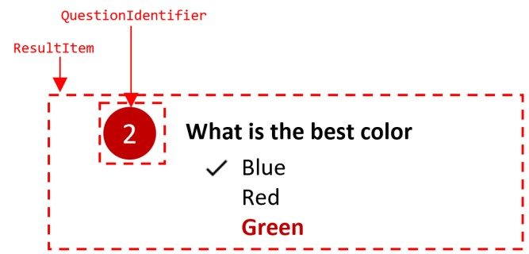

This widget takes as parameter a question and a player choice and handle the color computation, the choices highlighting etc..

